**Boundary value analysis:**

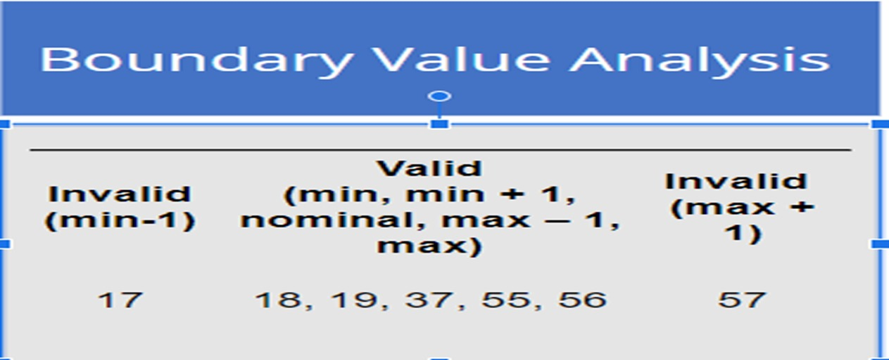

**How to Make Decision Table for Upload Screen**

**Specification:**

**The file should be in .png format.**

**The size of the file should be less than 25kb.**

